The Burrows-Wheeler Transform or BWT is a critical tool for searching and indexing biological sequences, particularly when the sequence in question is very long, as in the case of the 3-billion-character human genome. BWT’s advantage over other techniques lies in its ability to encode a long text in a way that is concise, compressible, and indexable for fast searching. The FM Index¹ is an example of a BWT-based data structure that exploits these features to achieve both a compact representation and exact matching in time linear in the length of the query. Unfortunately, computing the BWT of very long sequences can be difficult in practice. This is because most methods for computing the BWT require that the sequence’s suffix array (SA) be computed in its entirety first. Once the SA exists, the BWT is computed by simply iterating over SA according to this equation:

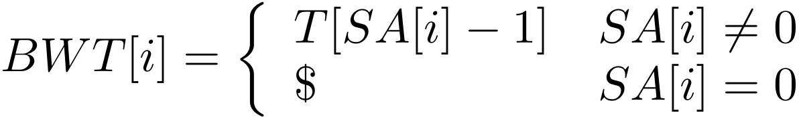

While this works well for sequences much smaller than the system’s physical RAM, building the SA for much longer sequences can quickly exhaust physical memory. Recent work by Kärkkäinen² proposes an alternate BWT-building technique that reduces the memory requirement to a fraction of that required by such approaches. Kärkkäinen’s insight is that the value of any given element of the BWT depends only on a single element of the SA. For this reason, constructing the entire SA at once is unnecessary; instead, the SA is built in blocks. As each block is constructed, it is converted to a segment of the BWT as usual. Concatenating all such segments yields the BWT. The overall algorithm in as follows:

- Select a random subset of the suffixes to be splitters
- Sort the splitters; each adjacent pair now delineate the edges of a bucket
- For each bucket
  - For each suffix, determine whether it falls into the bucket (i.e. is both greater than the low splitter and less than the high splitter)
  - Compute a block of SA by sorting all suffixes in the bucket
  - Calculate a BWT block from the SA block

Care must be taken to choose splitters that result in a relatively even distribution of bucket sizes. The target bucket size is a parameter to the algorithm. Another important aspect of the algorithm as set forth in the paper is the use of a difference cover (DC) sample, which will not be discussed in detail here. Suffice it to say that, while the DC helps the author achieve a desirable running-time bound for highly repetitive data in the paper, it is not necessary for correctness and it is unclear whether it substantially improves runtime in practice.
My goal is to implement a correct and robust version of Kärkkäinen’s algorithm for use both for my own research and by others in the Bioinformatics community. I expect that a basic tool implementing the algorithm can be achieved in three weeks. I also propose two “stretch goals” in the event that the implementation is completed with time to spare. The first stretch goal is to additionally implement the difference-cover (DC) technique described in the paper and characterize its affect on runtime. The second stretch goal is to profile and characterize performance in detail, including over ranges of values for the bucket size (bmax in the paper) and for the periodicity of the difference cover (v in the paper).

- Ferragina, P. and Manzini, G. 2000. Opportunistic data structures with applications. In Proceedings of the 41st Annual Symposium on Foundations of Computer Science (November 12 - 14, 2000). FOCS. IEEE Computer Society, Washington, DC, 390.
- Kärkkäinen, J. 2007. Fast BWT in small space by blockwise suffix sorting. Theor. Comp. Sci. 387, 3 Nov. 2007, 249-257

